tudent Id – IT24100108

Name – sanjana B A

Lab sheet 10

1

2

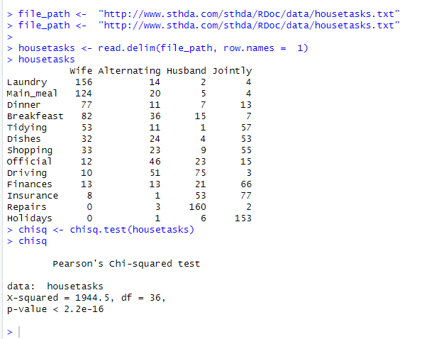

3

